EASTERN INTERNATIONAL UNIVERSITY | Practice Assignment – Quarter 4, 2025- 2026
SCHOOL OF COMPUTING  AND INFORMATION TECHNOLOGY | Course Name: ISAD  Course Code: CSW 309
Student’s Full Name: Vũ Đức Tùng
Student ID: 2331200132

LAB 05
UML Diagram Assignment

1. Objectives
After completing this session, students will be able to:
- Develop UML class, activity, state and sequence diagrams from one scenario.
- Apply correct UML notation for structural, behavioral and interaction modeling.
- Link UML diagrams to selected use cases and previously identified data entities.
- Check consistency among class responsibilities, object states and sequence messages.

2. Scenario to practice

Scenario 01: Online Library Book Borrowing System

A student uses an online library book borrowing system. The student can log in, search for a book by title or author, view book details, and submit a borrowing request. The system checks whether the selected book is currently available. If the book is available, the system creates a Borrowing Record, sets its status to Requested, and sends the request to the librarian. The librarian reviews borrowing requests and updates the status to Approved or Rejected. If the request is approved and the student collects the book, the librarian updates the status to Borrowed. When the student returns the book, the librarian updates the status to Returned. The student can log in at any time to check the borrowing status.

Requirements

Task 1- Draw a Use Case Diagram
- Identify actors
- Identify use cases
- Draw the system boundary
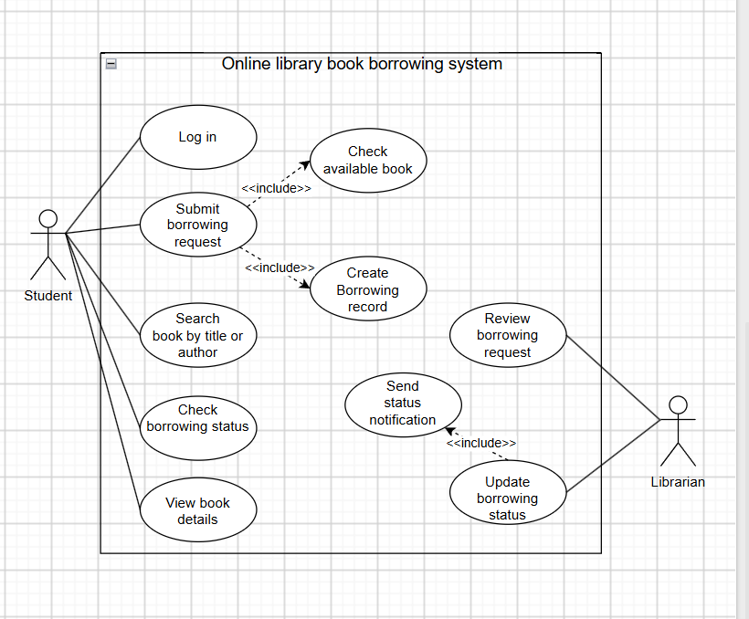

Task 2 - Draw one Activity Diagram
Draw an activity diagram to show the borrowing request process from:
- Student login
- Book search
- Request submission
- Availability checking
- Approval or rejection
- Borrowing and return status update
The activity diagram should include start/end nodes, actions, decisions and alternative flows.

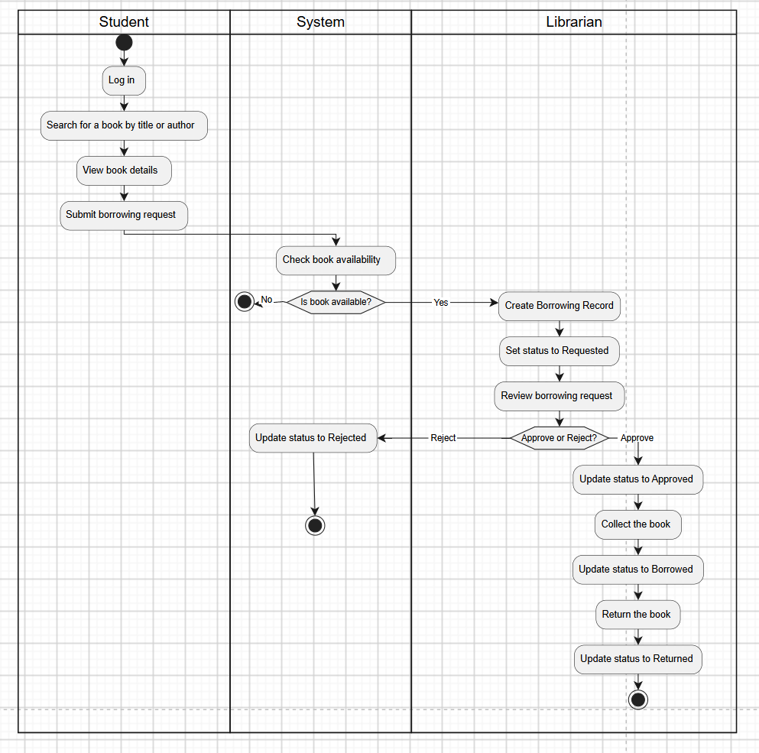

Scenario 02: Online Academic Service Request System
A university provides an online academic service request system for students. Each student has a student ID, full name, email, and program. A student can log in, choose one service type such as a transcript, enrollment certificate, or student letter, fill in a request form, upload one or more supporting documents, and submit the request. After submission, the system creates a Service Request with a request ID, request date, purpose, and status. Each request belongs to one student and one service type, and it may include many supporting documents. Academic staff log in to review submitted requests and check whether the provided information and attached documents are complete. If the request is incomplete or incorrect, the staff update the status to Revision Required, and the system sends a notification to the student. The student can then edit the request, upload additional documents, and resubmit it. If the request is valid, the staff approve it, the system issues the requested document, updates the status to Completed, and notifies the student. The student can log in at any time to check the request status.

Requirements

Task 1 - Draw a Use Case Diagram
- Identify actors
- Identify use cases
- Draw the system boundary
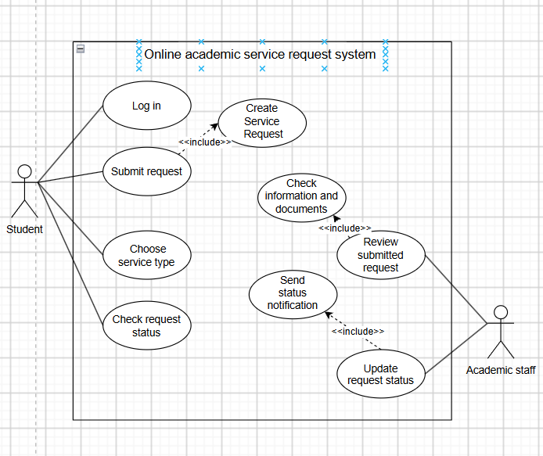

Task 2 - Draw a UML Class Diagram
- Identify main classes
- Add key attributes
- Show relationships between classes
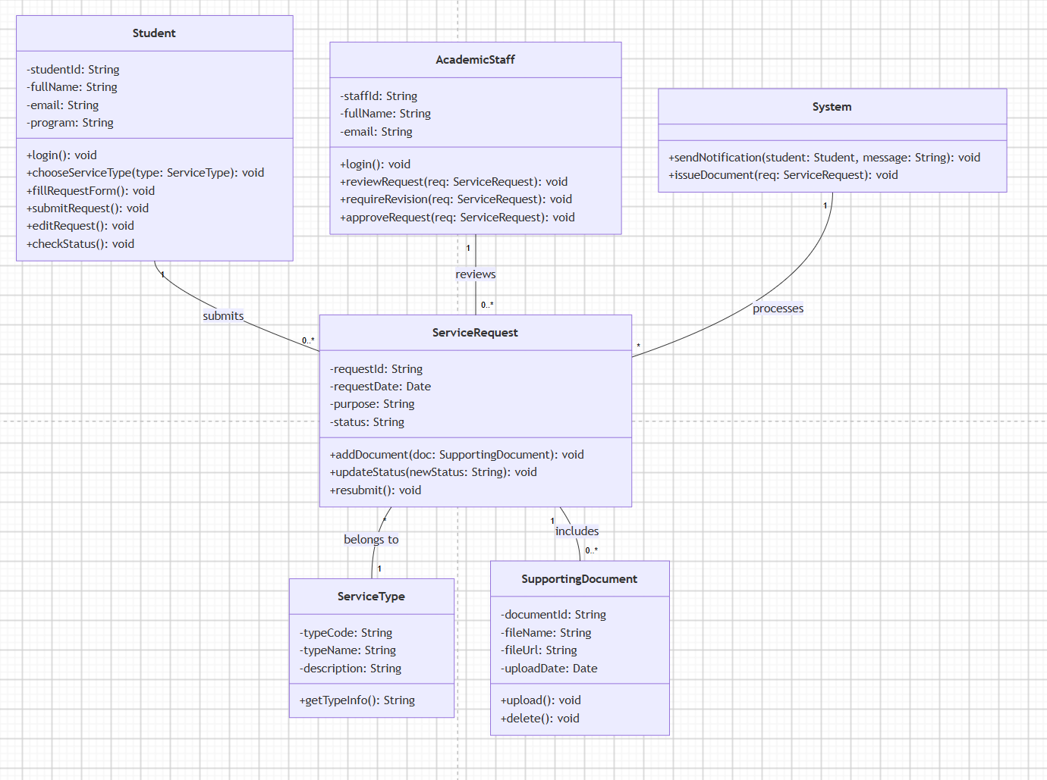

Task 3 - Draw one Sequence Diagram
Draw a sequence diagram for the use case: Submit and Review Service Request. Include actor, boundary/control/entity objects where suitable, messages and return messages.

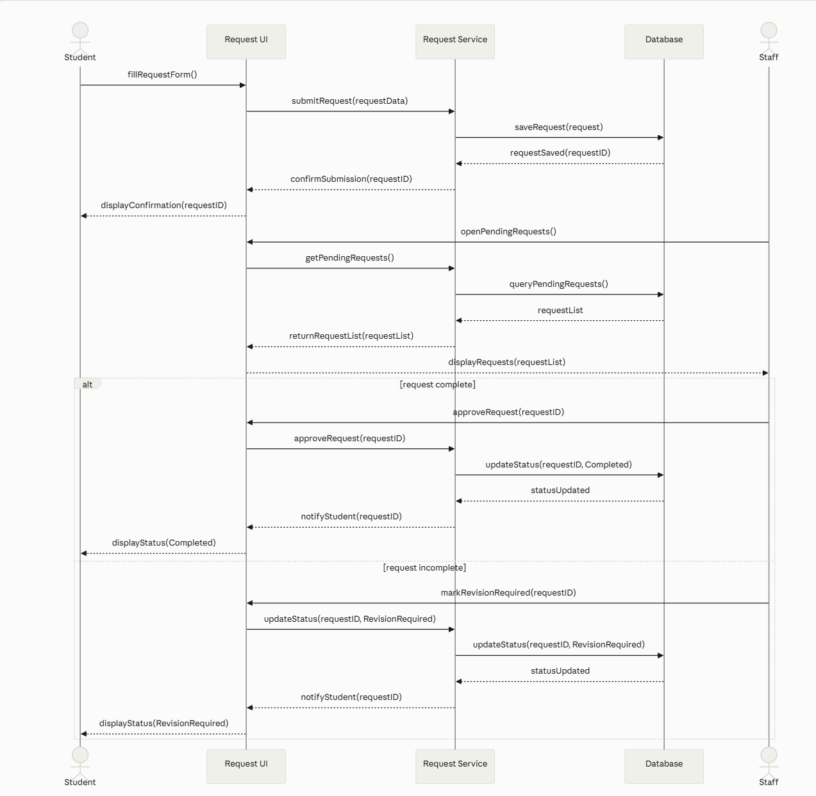

Scenario 03: Online Medical Appointment System
A patient uses an online medical appointment system. A patient can register an account with a patient ID, full name, phone number, and email, then log in, search for a doctor, view doctor details, and check available time slots. Each doctor has a doctor ID, name, specialty, and consultation schedule. Each available time slot has a slot ID, date, start time, end time, and availability status. The patient chooses one time slot and submits an appointment request. The system checks whether the selected slot is still available. If the slot is available, the system creates an Appointment with an appointment ID, appointment date, reason, and status Pending. Each appointment belongs to one patient, one doctor, and one time slot. A receptionist logs in to review appointment requests and updates the appointment status to Confirmed, Checked-in, Completed, or Cancelled. The patient can log in at any time to check the appointment status.

Requirements

Task 1 - Draw a Use Case Diagram
- Identify actors
- Identify use cases
- Draw the system boundary
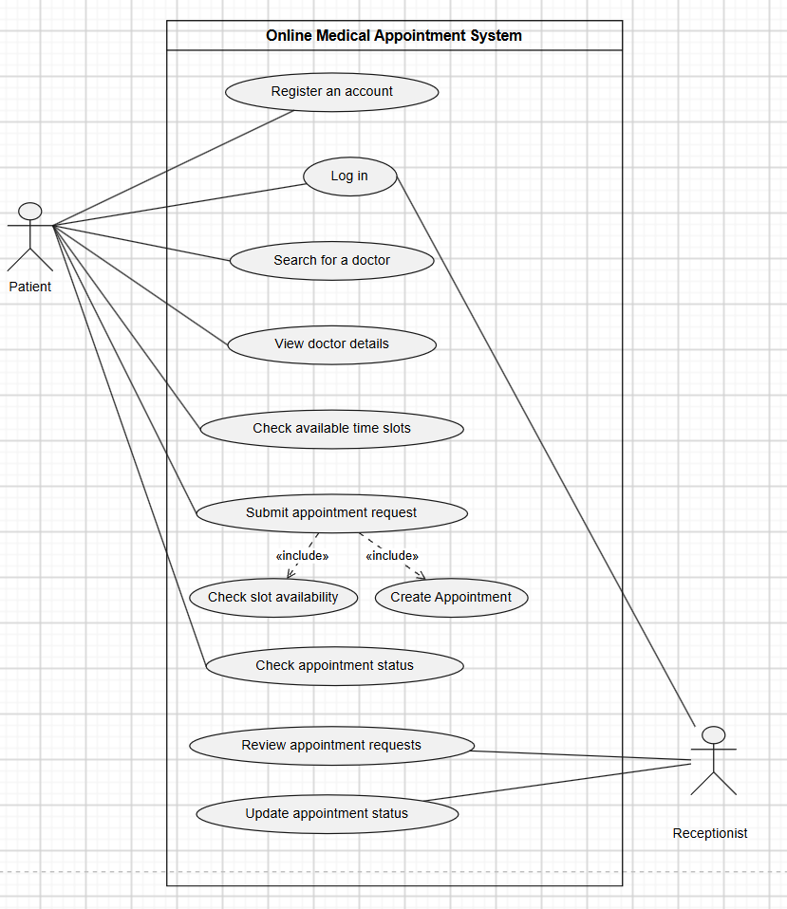

Task 2 - Draw a Basic Class Diagram
- Identify main classes
- Add key attributes
- Show relationships between classes

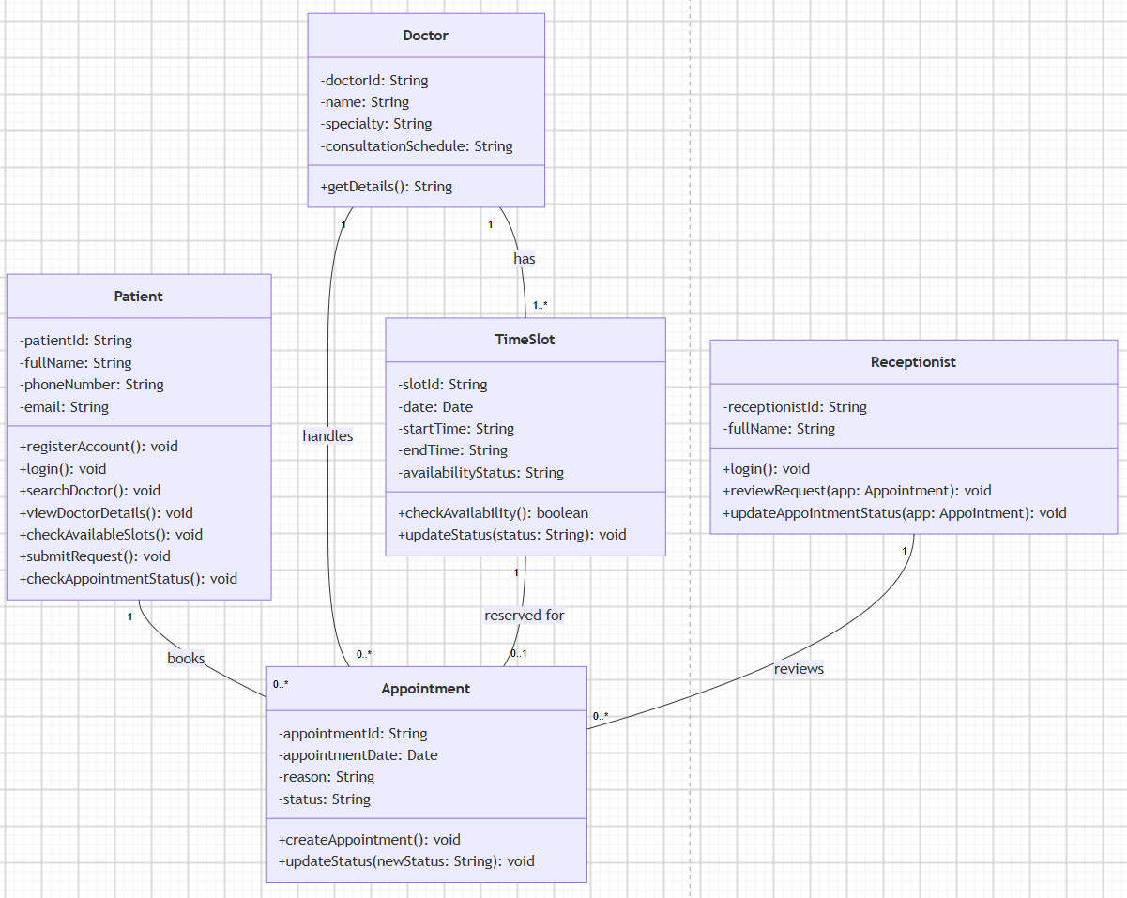

Task 3 - Draw one State Diagram
Draw a state diagram for the object: Appointment. Show states, events and transitions.

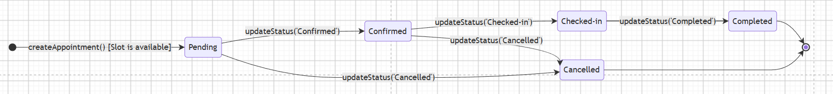

Scenario 04: University Clinic Appointment System
A university clinic wants to digitize its appointment booking process. Students can search clinic services, view available doctors and time slots, and submit appointment requests online. Each request includes the student, selected service, preferred doctor, date, time and reason for visit. The system records the request as pending and sends a submission notification.
Clinic staff review pending requests. They check doctor availability and service capacity, then approve or reject each request. When a request is approved, the system creates an appointment record with appointment date, time, doctor, service and status. Students can view appointment status and may reschedule an approved appointment once if they cannot attend. The system sends notifications when a request is submitted, approved, rejected or rescheduled. If a student misses an appointment without cancellation, the system records a missed-appointment warning.

Requirements
Complete the following tasks. This lab focuses on UML diagrams only. Do not design database tables or UI screens.

Task 1 – Draw use case diagram
- Identify actors
- Identify use cases
- Draw the system boundary

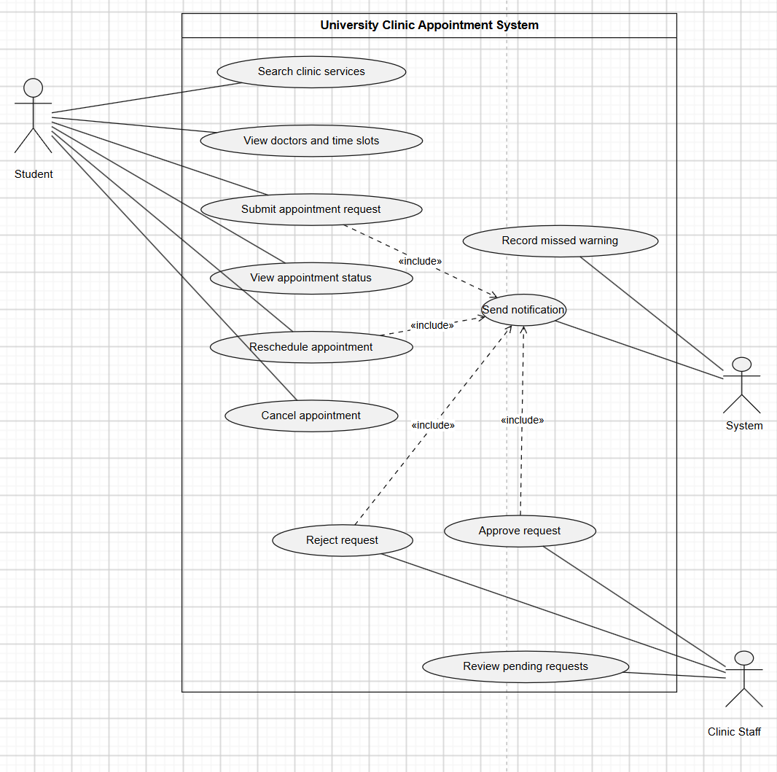

Task 2 - Draw UML class diagram
- Include at least 6 domain classes.
- Show attributes with data types and key operations.
- Show associations with multiplicities.
- Include at least one inheritance relationship where reasonable.
- Include at least one aggregation or composition relationship where reasonable.

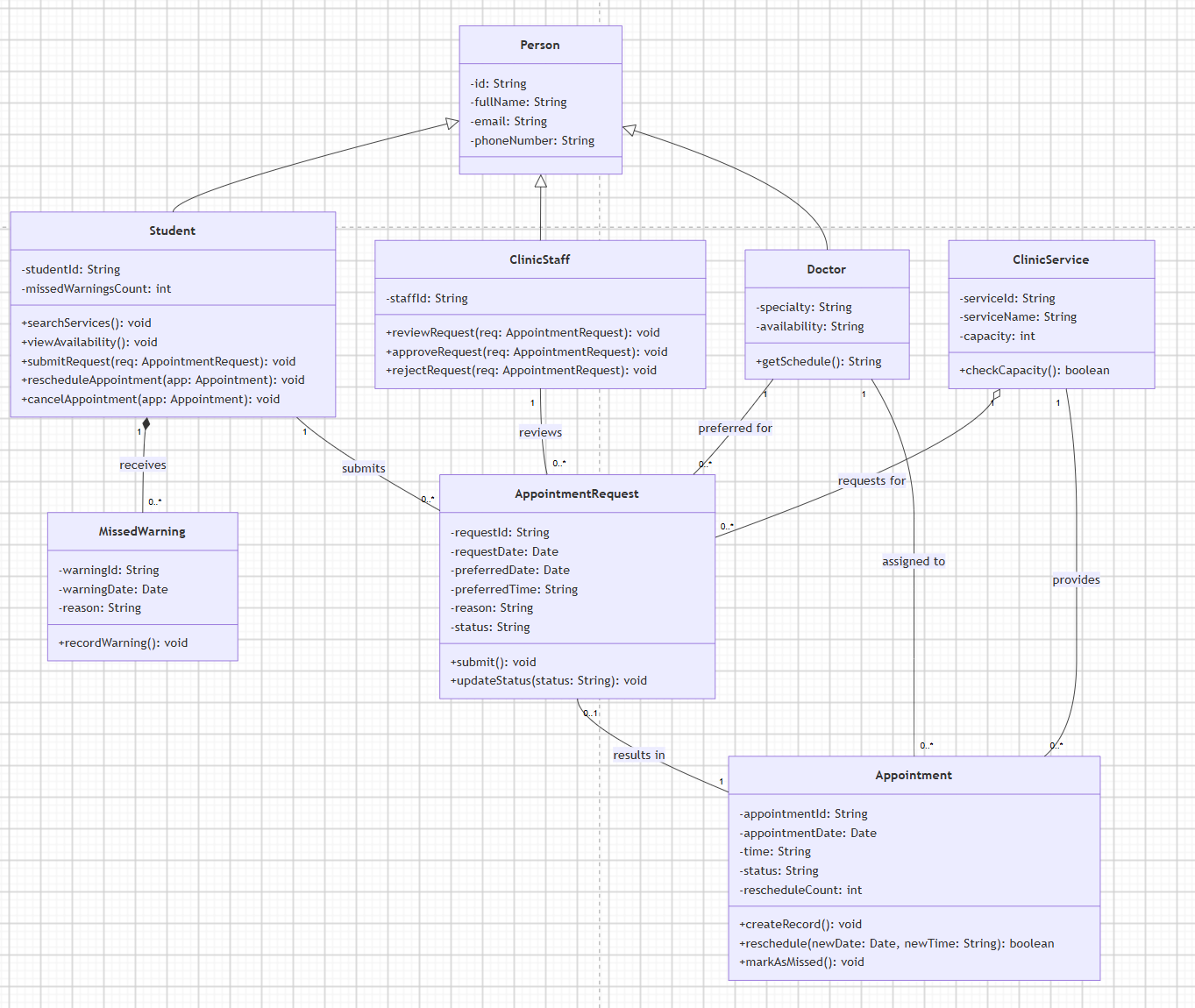

Task 3 - Draw activity diagram
Draw an activity diagram for Submit Appointment Request or Review Appointment Request. Include start/end nodes, actions, decisions and alternative flows.
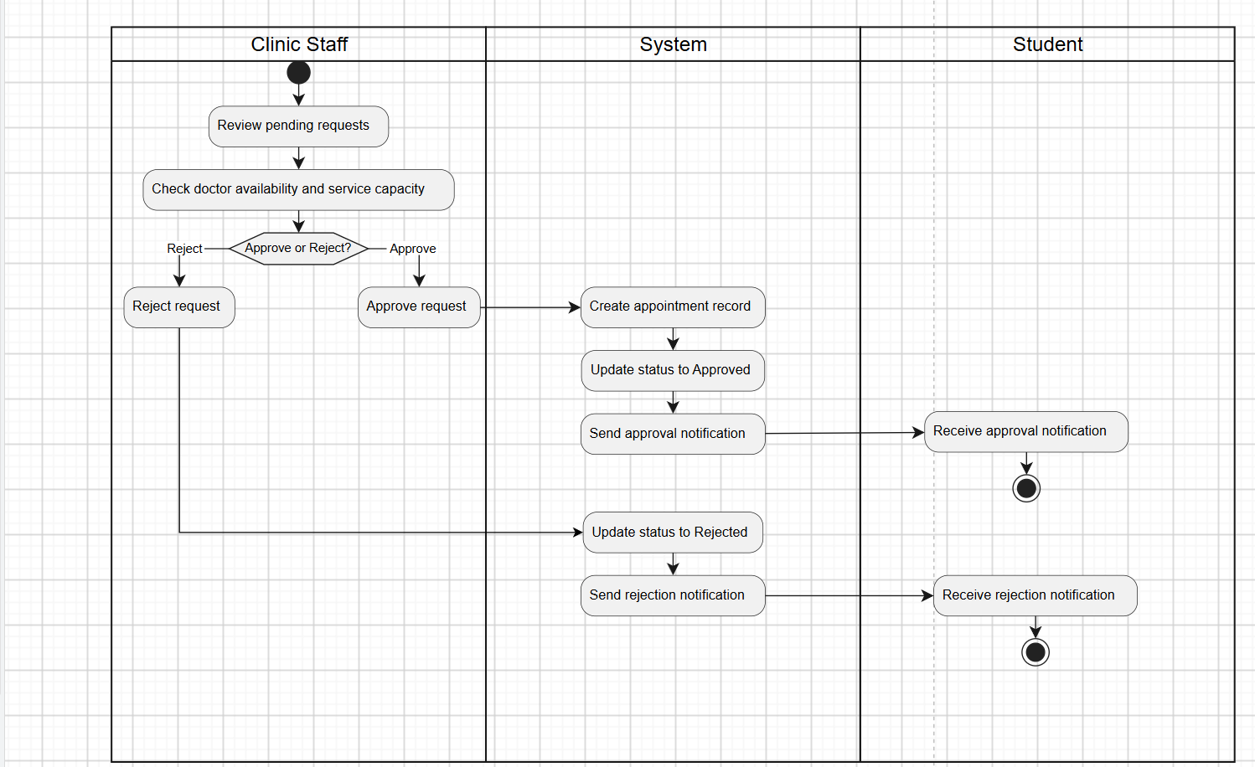

Task 4 - Draw state diagram
Draw a state diagram for Appointment Request or Appointment. Show states, events and transitions.
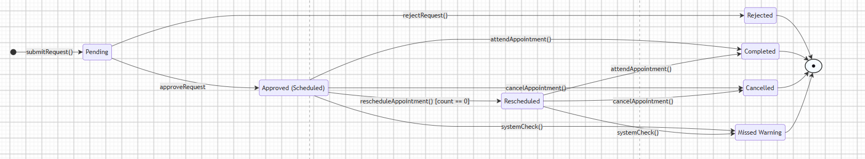

Task 5 - Draw sequence diagram
Draw a sequence diagram for Submit Appointment Request or Approve Appointment Request. Include actor, boundary/control/entity objects where suitable, messages and return messages.
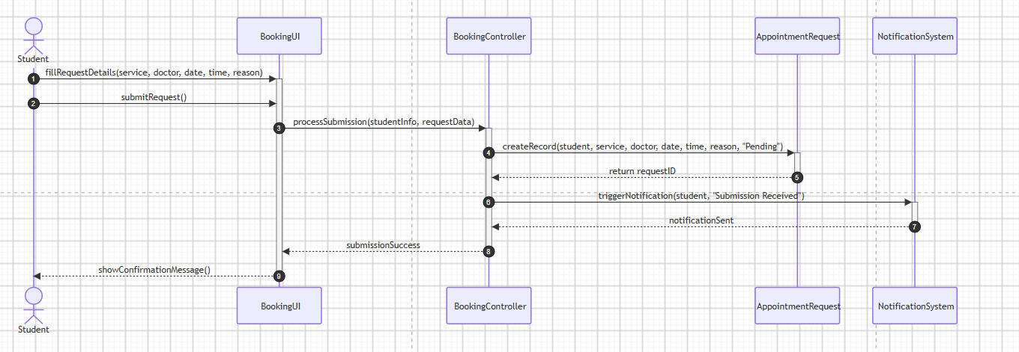

3. Assessment (100 points total)
Task # | Criteria | Points
Scenario 1 |  | 15
1 | Use case diagram
2 | Activity diagram
Scenario 2 |  | 25
1 | Use case diagram
2 | UML Class diagram
3 | Sequence diagram
Scenario 3 |  | 20
1 | Use case diagram
2 | UML Class diagram
3 | State diagram
Scenario 4 |  | 40
1 | Use case diagram
2 | Class diagram
3 | Activity diagram
4 | State diagram
5 | Sequence diagram

4. Submission
Submit one PDF report and editable diagram file(s). File name format: CSW309_Lab05_StudentNo_StudentName.

5. Notice for Student
- Do not use database table names as class names unless they are also meaningful domain concepts.
- Do not draw an activity diagram like a DFD; activity diagrams show workflow and decisions.
- Sequence diagram messages should correspond to operations or responsibilities in the class diagram.

